**What/Why Kubernetes?**

* It is an open source tool for automating deployment, Scaling and managing containerized applications.
* System for running many different containers with different images over multiple machines.

**How to communicate with the Kubernetes Master?**

Kubectl is a command line interface for running commands against Kubernetes clusters.

**How does nodes in the cluster communicate with the master?**

* Each node has a Kubelet, which is an agent for managing the node and communicating with the Kubernetes master.
* The node should also have tools for handling container operations, such as Docker.

**NOTES:**

* Kubernetes expects all images to be already built.
* Requires one config file to create an object.
* We have to manually set up networking in Kubernetes.

Objects serves different purposes like running a container, monitoring a container and setting up networking, etc...

POD:

* It is the smallest object in the Kubernetes environment that you create or deploy.
* Runs one or many containers.
* Pod groups containers with same purpose.

SERVICE:

* It is used to setup networking in Kubernetes.

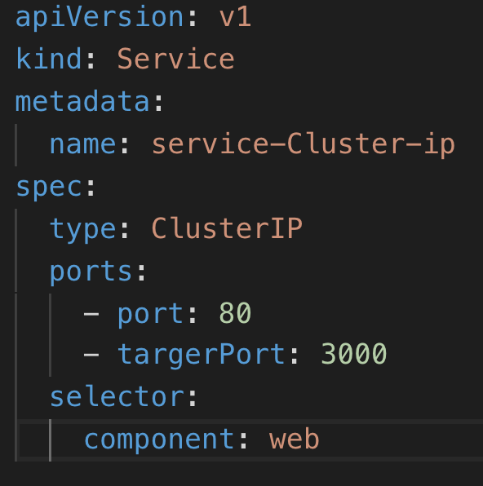

Types of Services:

Load Balancer:

Ingress:

Limitations in config file updates:

* You can only update the Image Name / Version, active Deadline, tolerations property of a pod.

Deployment:

It is a Kubernetes object that maintains a set of identical pods.

Kubernetes Commands:

Volumes:

DEMO TIME

NODE Image

